**Task 4- OLAP Operations (using Redshift or PostgreSQL)**

1. Drill Down- Analyze sales data by breaking it down from the region level to the product level.

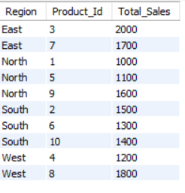

1. Rollup- Summarize sales data at different levels, such as region totals.  
     
   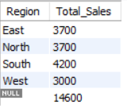
2. Cube (Analyze Sales by Product, Region, and Date)- Generate aggregated data for all combinations of product, region, and date.  
   
3. Slice (Filter Sales Data by Specific Region)- Analyze sales data for a specific region (e.g., North).

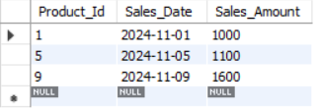

1. Dice (Filter Sales Data for Multiple Conditions)- Analyze sales data for specific regions and a specific time range.

